**Laboratory 6:**

Diffraction and Interference

**Name:** Omar Ozgur

**Date:** Feb 25, 2016

**Lab:** Section 7, Thursday 8:00am

**TA:** Nicholas Rombes

**Lab Partners:** Abdullah Albanyan, Patrick Xu, Vaqar Syed

**1. Introduction**

The purpose of this experiment was to use investigate various properties of light, such as diffraction and interference. In the first section of the experiment, a laser was directed through a single slit, toward a fiber optic cable that was attached to a photometer. By monitoring the voltage output of the photometer while moving the cable perpendicularly to the beam of light, the light intensity profile of the laser could be examined. In the second portion of the lab, a similar procedure was used in order to analyze the light intensity profile of the laser when it was passed through each of 4 different double-slit diffracting elements. In the third section of the lab, the laser was passed through a grating with 600 lines/mm, and a protractor was used to measure the angles between adjacent maxima. This data could be used to determine the experimental slit spacing of the diffracting element. In the next part of the experiment, a ray box was used to pass a collimated sheet of light through the same grating that was previously used. This caused the white light to split into rays of different colors, and the angles of the colored rays from the central ray were used to determine the frequencies of the colored light. In the last portion of the experiment, a diffraction pattern was created by directing a laser beam at a vertical strand of hair. The distance between adjacent maxima was used to help determine the thickness of the hair. The results of these experiments helped to verify theoretical ideas involving the wave-like behavior of light.

**2. Experimental Results**

2.1 Detector Response

In the first section of the experiment, the goal was to measure the profile of a laser without the effects of diffraction. In order to do this, a laser emitter was placed on one end of an optical bench, and a fiber optic cable was connected to a linear translator on the other end of the bench. The fiber optic cable was connected to a photometer that had been calibrated to produce accurate readings with minimal light input. Afterwards, the laser beam was directed towards the fiber optic cable, and the photometer was used to measure the relative intensity of the light. Fine adjustment knobs were used to allow the laser to hit the cable accurately, and the photometer sensitivity was readjusted in order to provide readings with the most precision. This produced a reading of 24 ± 3 lx. The setup is shown in figure 1. However, no diffracting elements were used until later in the experiment.

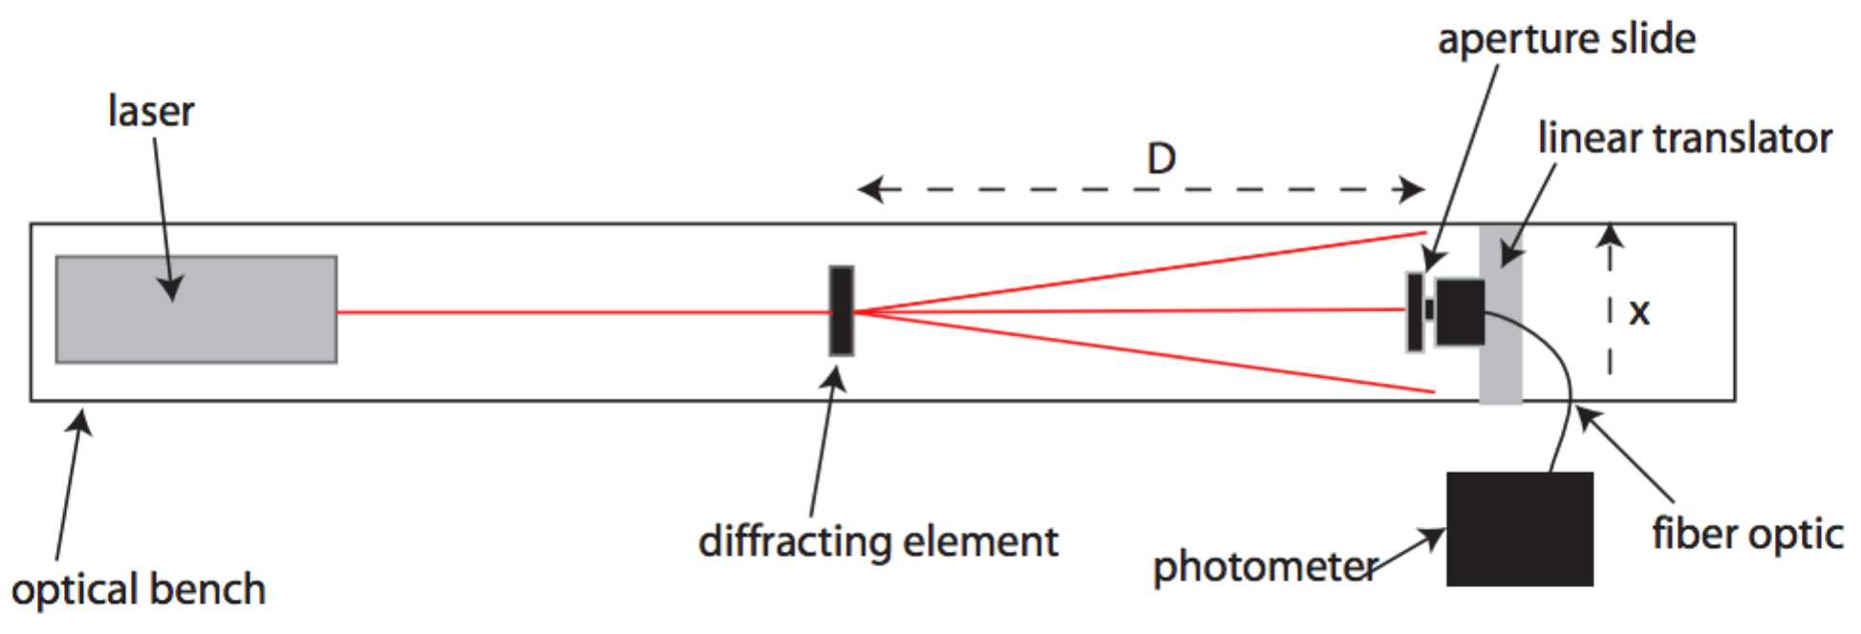

Figure : Setup to Measure Intensity of Light: This image shows the setup that was used for multiple portions of this laboratory experiment. A laser emitter was placed at one end of an optical bench so that the light was directed towards a fiber optic cable at the other end of the bench. A linear translator was used to adjust the position of the cable, and a photometer was used to measure the intensity of light that was hitting the cable. This setup could be used to measure the intensity profile for light passing through various diffracting elements. (Source: UCLA Physics 4BL Lab Manual, Winter 2016)

In order to improve the detector’s spatial resolution, a 0.1 mm slit was placed in front of the optic cable so that the incoming light intensity was reduced. This caused a maximum intensity of 8 ± 1 lx to be read on the photometer. The next step in the experiment was to calibrate the potentiometer that was attached to the linear translator that moved the fiber optic cable. In order to do so, a DC voltage of 5.0 ± 0.5 V was supplied to the potentiometer, and the output voltage was recorded through the use of a multimeter. Measurements were taken at linear position intervals of 5.0 ± 0.5 mm. The results are shown in figure 2. By using a regression analysis tool in Microsoft Excel, the slope of the linear trend line was found to be 9.42 ± 0.03 mm/V, which was used in order to convert voltage readings to linear position.

Figure : Potentiometer Calibration: This graph shows the recorded voltage readings from the potentiometer at 5 different positions along a linear translator. After performing linear regression analysis on the data with Microsoft Excel, the slope of the linear trend line was found to be 9.42 ± 0.03 mm/V, which could be used in order to convert voltage readings to positions.

In order to determine the intensity profile of the laser beam, voltage readings from the potentiometer were recorded through channel 0 of an analog to digital converter (ADC), and voltage readings from the potentiometer were recorded through channel 1. By using the provided “4BL” software, data was recorded at a rate of 100 points/sec while the handle of the linear translator was rotated at a rate of approximately 3 rotations per second. The voltage readings from the potentiometer were converted to position measurements based on the calibration constant shown above. The recorded profile is displayed in figure 3. It was observed that the maximal detector response occurred when the light hit the fiber optic cable directly.

Figure : Detector Response: This data shows the recorded intensity profile of the laser beam without the use of any diffracting elements. Each data point represents the voltage recorded by the potentiometer when the fiber optic cable was at the specified position along a linear translator. The intensity rose to the highest point when the cable was at a position of 28.0 ± 0.5 mm along the translator. This data could be compared to the profiles that were found when the laser beam was passed through various diffracting materials.

2.2 Double Slit Diffraction / Interference Patterns

In this section of the experiment, the goal was to measure diffraction patterns in order to determine the slit width and separation of double slit diffraction gratings. In order to begin, a slide support was placed at a distance of 39.0 ± 0.5 cm from the detector. Afterwards, a slide with 4 different slits was placed so that the laser beam passed through a slit labeled “A”. This slit was known to have a width of 0.04 mm, and a spacing of 0.125 mm. By placing a sheet of paper at various distances from the slit, the diffraction pattern could be seen. After adjusting the photometer sensitivity to produce responses of adequate scale, the procedure described in section 2.1 was repeated in order to record the laser profile through the use of a myDAQ system. The data is displayed in figure 4. The distances between adjacent maxima and minima could be used to calculate the slit width and separation. This portion of the experiment was repeated three more times with slits “B”, “C”, and “D” of unknown width and spacing. The recorded data is shown in figures 5, 6, and 7.

Figure : Laser Profile for Slit "A": This graph displays the recorded laser profile data after the light was passed through slit “A”. As the position of the fiber optic cable was changed, the amount of light that hit the cable also changed. The peaks shown on this graph occurred when the cable was at locations of high relative light intensity. This data could be used to calculate the slit width and spacing, which could be compared to the known values for the slit.

Figure : Laser Profile for Slit "A": This graph displays the recorded laser profile data for light passing through slit “B”. The positions of relative maxima and minima could be analyzed in order to calculate the slit width and spacing. These values could be compared with those calculated based on slits “A”, “C”, and “D”.

Figure : Laser Profile for Slit "C": This graph displays the recorded laser profile data for light passing through slit “B”. The positions of relative maxima and minima could be analyzed in order to calculate the slit width and spacing. These values could be compared with those calculated based on slits “A”, “B”, and “D”.

Figure : Laser Profile for Slit "D": This graph displays the recorded laser profile data for light passing through slit “B”. The positions of relative maxima and minima could be analyzed in order to calculate the slit width and spacing. These values could be compared with those calculated based on slits “A”, “B”, and “C”.

2.3 Diffraction Grating

In the next portion of the experiment, a laser of wavelength 670 nm was directed through a diffraction grating with 600 lines/mm. Placing a beam expander horizontally in front of the laser produced a vertical sheet beam that made it more easy to recognize the diffraction pattern. By placing a white sheet of paper in front of the diffracted light, bright spots could be clearly seen where the light was constructively interfering. In order to measure the angles between successive maxima, a protractor was placed on the transmission side of the diffraction grating so that the light was projected onto it. The protractor was placed so that the brightest ray was located at an angle of 90.0 ± 0.05 °. The angles of the two rays on the left and right of the central ray were recorded as well. The recorded data is displayed in table 1. The uncertainty in the measurements was determined based on the divisions of the protractor that was used.

|  |  |
| --- | --- |
| **Ray** | **Angle with respect to 90° (°)** |
| Left Ray | 25.0 ± 0.5 |
| Central Ray | 0.0 ± 0.5 |
| Right Ray | 25.0 ± 0.5 |

Table : Angles of Adjacent Maxima: This table displays the recorded angles of adjacent maxima based on a laser of wavelength 670 nm that was passed through a diffraction grating with 600 lines/mm. A beam expander was used to make the diffraction pattern clearer, and the light rays were projected onto a projector in order to record the angles. The angles of the left and right rays were found to be symmetrical, as expected based on theoretical results.

2.4 Dispersion of White Light by a Grating

In the next section of the experiment, a metallic baffle was placed in front of a ray box in order to allow for the production of a vertical sheet of collimated light. This box was oriented so that the light passed through a diffraction grating with 600 lines/mm, causing rays of multiple colors to be produced on the transmission side of the grating. By placing a sheet of paper in front of the diffracted light rays, the separation of light into various colors could be easily seen in multiple spots. By allowing the light rays to be projected onto a protractor, the diffraction angles of the red, green, and blue rays could be measured on both sides of the central ray. This data could be used to calculate the wavelengths of these colors. The separation of light is depicted in figure 9.

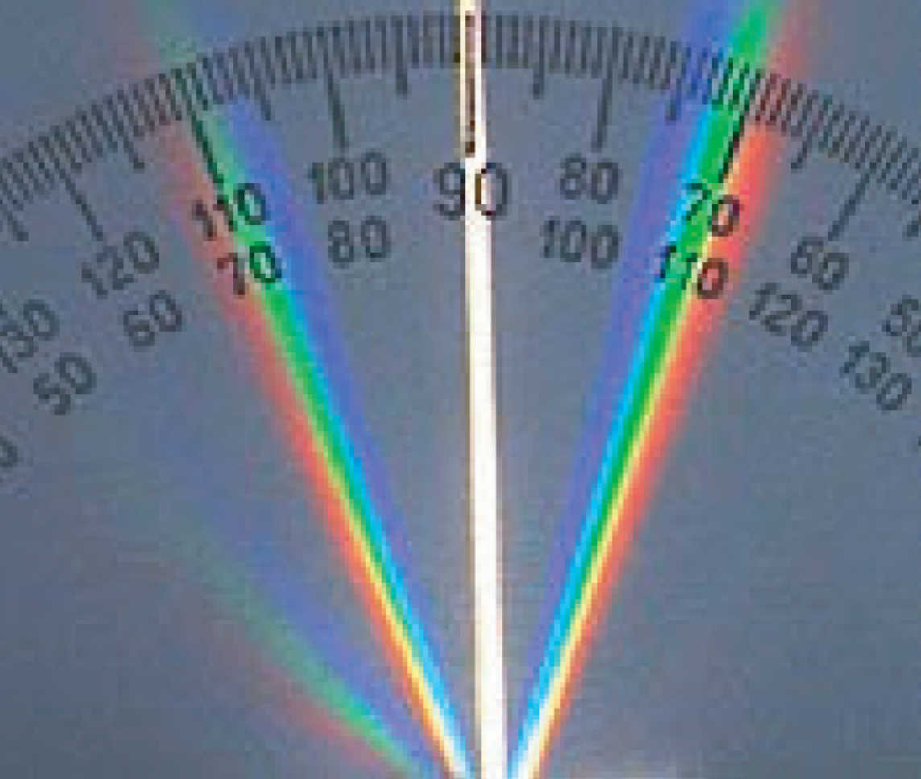

Figure : Separation of White Light: After white light was passed through a grating with 600 lines/mm, the light was separated according to wavelength, as shown in this image. A protractor was used to determine the angle of each ray in relation to the central ray. This information was used to determine the frequency of light of each color. (Source: UCLA Physics 4BL Lab Manual, Winter 2016)

The recorded data is displayed in table 2. The uncertainties were determined based on the divisions of the protractor that was used. The uncertainty was increased due to the fact that each ray was seen to span multiple angles on the protractor.

|  |  |
| --- | --- |
| **Ray** | **Angle with respect to 90° (°)** |
| Red (Left of central angle) | 24 ± 2 |
| Green (Left of central angle) | 20 ± 2 |
| Blue (Left of central angle) | 16 ± 2 |
| White (Central angle) | 0 ± 2 |
| Blue (Right of central angle) | 17 ± 2 |
| Green (Right of central angle) | 21 ± 2 |
| Red (Right of central angle) | 25 ± 2 |

Table : Angles of Diffracted Colors: This table displays the recorded angles of the light rays that were produced by passing white collimated light through a diffraction grating with 600 lines/mm. Based on the angles of the red, green, and blue rays that were produced, the wavelengths of these colors could be calculated. Based on the given uncertainty ranges, it could be seen that the angles of the rays to the left of the central ray were symmetrical to those of the rays on the right.

2.5 Additional Diffraction Measurements

In the last portion of the experiment, the goal was to determine the thickness of a hair by analyzing the diffraction pattern that it produced. In order to do so, one lab member pulled a hair from his head, and placed it in front of a magnetic slide support. Two pieces of metal were used to hold the hair vertically in place. Afterwards, the laser that was used in previous sections of the experiment was directed towards the hair so that a diffraction pattern could be clearly seen on a piece of paper that was placed on the transmission side of the light.

In order to clearly view the positions of adjacent maxima, the paper was placed far from the strand of hair. This caused the light to appear brightest at positions where the diffracted light was constructively interfering. The spacing between these points was observed to be constant. The distance from the hair to the paper was found to be 520 ± 5 cm. The uncertainty in this measurement was determined based on the fact that a ruler with a length of 60.0 ± 0.5 cm had to be moved 10 times in order to measure the distance. Based on the diffraction pattern that was produced, the distance *δx* between adjacent maxima was found to be 4.0 ± 0.5 mm. The uncertainty in this measurement was based on the divisions of the ruler that was used.

**3. Analysis**

3.1 Detector Response

Based on the calibration data from the potentiometer that was used in this experiment, it was seen that the data points were consistent with a linear trend. By performing regression analysis on the data through the use of Microsoft Excel, the equation of the line was found, which is displayed in equation 1. This equation was useful later in order to convert voltage readings *V* from the potentiometer to measurements of position *x*.

(1)

3.2 Double Slit Diffraction

Based on the data that was gathered while passing light through double-slits labeled “A”, “B”, “C”, and “D”, the distances *Δx* between maxima and minima could be used to calculate slit separation *d*, and the distance between the envelope minima could be used to calculate slit width *b*.

In order to calculate the slit width, equation 2 was utilized, where *θ* represents the angular position of the maxima, *m* represents the number of the minima that was used, and *λ* represents the wavelength of the laser. In this experiment, the wavelength was known to be 670 nm with negligible uncertainty. Since *θ* was close to 0°, sin(*θ*) was approximated as tan(*θ*), as shown in equation 3. This allowed for equation 2 to be rewritten as equation 4 in order to calculate the slit width *b*. In this equation, *D* was used to represent the distance from the diffraction grating to the detector, which was measured to be 39.0 ± 0.5 cm. The slit width calculation was performed based on data for the “known” slit labeled “A”, as well as for the slit with the largest slit spacing. The calculated results are displayed in table 3. The uncertainty in these values was found through the use of the propagation of error formula shown in equation 5.

(2)

(3)

(4)

(5)

Based on the same theoretical approach, equation 6 was used to calculate the slit separation *d*. The only difference from equation 4 was that *Δx* was based on the distances between adjacent maxima and minima instead of the width of the entire envelope. The averages of separations were calculated, which are displayed in table 3. Since many maxima and minima were used to find these values, the uncertainties were found by taking the standard deviation of the mean spacing values.

(6)

|  |  |  |
| --- | --- | --- |
| **Slit Label** | **Slit Width *b* (mm)** | **Slit Separation *d* (mm)** |
| A (Known) | 0.045 ± 0.006 | 0.11 ± 0.05 |
| B (Unknown) | 0.046 ± 0.005 | 0.42 ± 0.08 |
| C (Unknown) |  | 0.26 ± 0.02 |
| D (Unknown) |  | 0.18 ± 0.03 |

Table : Slit Width and Separation: This table displays the calculated measurements of slit width *b* and slit separation *d* for slits labeled “A”, “B”, “C”, and “D”. This was done by utilizing data shown in figures 4, 5, 6, and 7, along with equations 4, 5, and 6. The values found for the slit labeled “A” could be compared with the theoretical values that were given in order to analyze the accuracy of the experimental results.

Based on the values *b =* 0.04 mm and *d* = 0.125 mm that were given for the slit labeled “A”, it could be seen that the calculated values *b* = 0.045 ± 0.006 mm and *d* = 0.11 ± 0.05 mm did agree with the theoretical results. This helped to verify the accuracy of the methods that were used to record and calculate data. By analyzing the graphs of minima and maxima in respect to the calculated slit separation values for all 4 slits, it could be seen that increasing the slit spacing caused adjacent maxima and minima to appear closer together.

3.3 Diffraction Grating

By visually analyzing the diffraction pattern that was created by passing light through a grating with 600 lines/mm, it could be seen that the large number of slits caused the light to clearly split into multiple rays, with angles symmetric to the central ray. Based on the measured angles of the rays, which are shown in table 1, the spacing *d* of the grating slits could be calculated through the use of equation 6, which was derived from equation 2.

(6)

Based on the average angle (25.0 ± 0.5)° of the light rays seen to the left and right of the center ray, and the wavelength of 670 nm that was used, the slit spacing was found to be 0.00159 ± 0.00003 mm. The uncertainty in this value was calculated based on the propagation of uncertainty formula shown in equation 5.

Since the diffraction grating had 600 lines/mm, the theoretical slit spacing was 0.00167 mm, with negligible uncertainty. By comparing this value to the experimental value, it could be seen that although the values were very close, they did not agree with each other based on the given error bounds. However, the percentage of error was only about %4.8, which may have been due to inaccuracy while measuring the angles of light rays.

3.4 Dispersion of White Light by a Grating

Based on the data that is displayed in table 2, the angles of red, blue, and green light rays that were generated by passing white collimated light through the diffraction grating could be used to help verify the results of equation 7. In this equation, *d* represented the theoretical slit spacing of 0.00167 mm, *n* represented the number of the maxima that was used, and *θ* represented the angle of the light ray that was being analyzed. Equation 9 was formed by rearranging equations 7 and 8, and was used to calculate the frequency of each color of light. In this equation, *f* represented the frequency of the light ray, and *c* represented the speed of light.

(7)

(8)

(9)

The calculated frequencies based on equation 9 are displayed in table 4. The uncertainty in these values was calculated through the use of the propagation of error formula shown in equation 5.

|  |  |
| --- | --- |
| **Ray Color** | **Frequency (Hz)** |
| Red |  |
| Green |  |
| Blue |  |

Table : Frequencies of Visible Light: This table displays the calculated frequencies of red, green, and blue light based on the diffraction of white light. These values could be compared to theoretical frequencies in order to help verify the accuracy of the equations that were used.

By analyzing the calculated frequencies of colored light, it could be seen that these values agreed with the theoretical frequency ranges of those colors. This result helped to verify the accuracy of the procedures that were used.

3.5 Additional Diffraction Measurements

Based on the diffraction pattern that was generated by pointing a laser beam at a vertical strand of hair, the thickness of the hair could be calculated. Since the hair acted as a single slit, equation 4 could be used to calculate the thickness. In this case, the distance *D* from the hair to the paper was measured to be 520 ± 5 cm, the distance *Δx* between adjacent maxima was measured to be 4.0 ± 0.5 mm, and the wavelength *λ* was taken to be 670 nm. Based on this information, the thickness of the hair was calculated to be 0.87 ± 0.04 mm. The uncertainty in this value was found through the use of the propagation of error formula shown in equation 5.

**4. Conclusion**

Most of the results of this experiment were successful in helping to verify theoretical equations and ideas involving diffraction and interference of light. In the first section of the experiment, the calculated slit width and slit spacing values based on recorded laser profile data agreed with theoretical results, which helped to verify the accuracy of the methods that were being used to gather data. In the next portion of the lab, a laser beam was diffracted, and the angles of transmitted rays were used to calculate the slit spacing. The calculated spacing value did not agree with the theoretical value in this case, but the low error percentage of approximately %4.8 showed that this was likely due to the difficulty involved in measuring the angles of light rays. In another section of the lab, red, green, and blue light rays were generated by diffracting a collimated sheet of white light. The angles of these rays with respect to the central ray were used to successfully calculate the frequencies of the colored light. In the last portion of the experiment, a laser beam was diffracted through the use of a strand of hair, and the diffraction pattern was analyzed in order to calculate the thickness of the hair. Based on the results of the experiment, it could be seen that the procedure allowed for the successful analysis of diffraction and interference of light.